**Module 3 – Network Layer**

Vipin Das

SAINTGITS College of Engineering.

**Network Layer**

The data unit in network layer is known as **Packet.**

The basic function of the network layer is the delivery of the packet from source network to the destination network.

There are algorithms that will help us to determine the path in which the transfer should take place.

Special hardware devices known as **Routers** does this job.

Computer Networks – Andrew S Tanenbaum**2**

**Network Layer operation.**

The packets follow a **store and forward** mechansim. There will be intermediate routers in the path.

The packets that is incoming to the router will be stored and will be forwarded in the best possible path.

This mechanism of delivering the packets on the best possible path is referred to as **switching**.

Since the packets are stored before switching the entire process is known as **store and forward switching.**

**3**

**Network layer environmment**

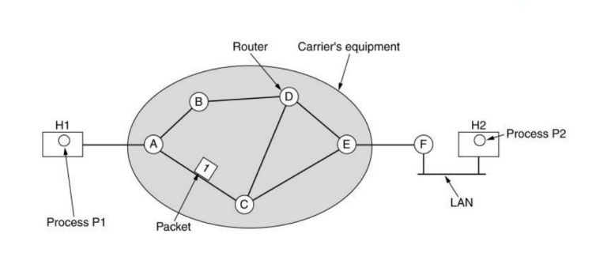**4**

**The establishment of path**

A packet needs to travel on the best possible path . There are two startegies to forward the packet. **Routing algorithms** determine the path in both cases. 1.Establish the full path before sending the packet. - The path is known as **Virtual Circuit subnet**.

-It is a connection oriented service as initial setup is involved.

2.Just forward the packet and determine the best path for individual packets.

-The path is known as **Datagram subnet**.

-It is a connectionless service as no prior setup is involved.

**5**

**Datagram Subnet**

In datagram subnet individual packets from source to destination may follow different paths.

This is because the routing algorithm might have learned about another best path.

Or path older path might have issues such as delay.

Every router maintains a table with the next best path to destination.

**6**

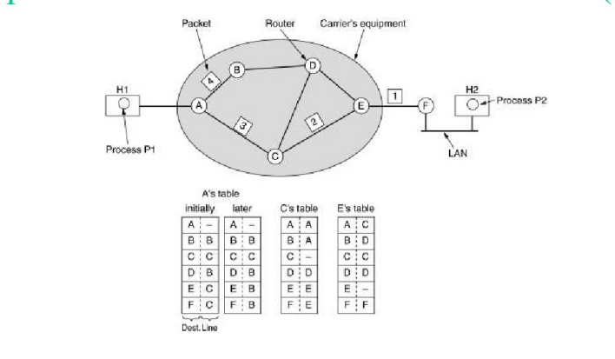**7**

**Virtual Circuit Subnet**

In virtual circuits every incoming packet will be given an identifier.

The identifiers are chosen by the sending process. If there are conflicts ,resolution is done by routers.

Intermediate routers forward the packet by looking at the identifiers.

**8**

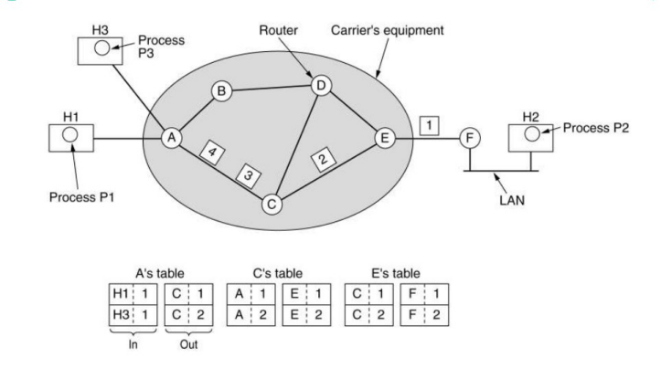**9**

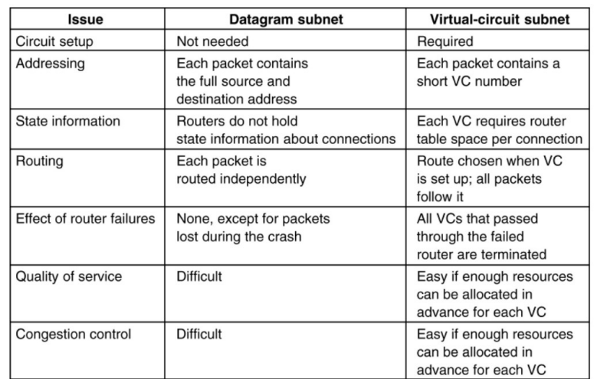**Comparison**

**10**

**Routing algorithms**

Routing algorithms decide on selecting the best output line for the incoming packets.

If datagram network is used ,this decision has to be taken for each packet.

If virtual circuit is used,this decision is taken initially and is valid for the entire session.**(Session Routing)**

**Non Adaptive algorithms -> The decision on best route does not depend upon current network conditions.A precomputed route is used.**

**Adaptive algorithms-> Made to adjust to changing topology and network conditions.**

**11**

**The optimality principle**

If router **J** is on an optimal path from router **I** to router **K**,then the optimal path from router **J** to router **K** also falls along the same path.

A set of optimal routes from all sources to a destination forms a tree routed at the destination,known as **sink tree**.

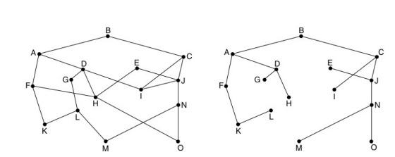**12**

**Shortest path algorithm**

The distance is usually measured in hops.

**Hop count may be equated to the number of devices.**

One such algorithm is **Dijkstras shortest path algorithm** (1959).

✔Considers the network as a directional graph . ✔The cost of reaching the neighbouring nodes is known.

✔The distance to self is zero and all other nodes are taken as inifinity in the initial condition.

✔The shortest distance between two nodes is calculated based on the cost and current node.

**13**

**Dijkstras Algorithm**

S = {}; d[s] = 0; d[v] = infinity for v != s While S != V

Choose v in V-S with minimum d[v]

Add v to S

For each w in the neighborhood of v

d[w] = min(d[w], d[v] + c(v, w))

**14**

**Example**

Source **A**. Destination **D**

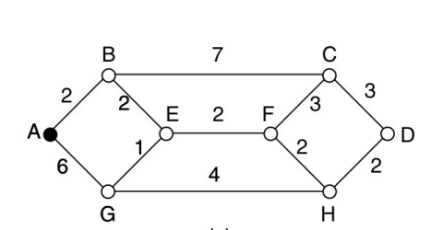**15**

**Final output**

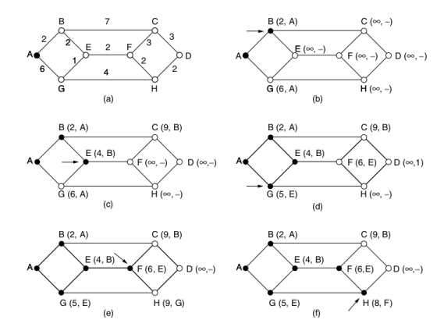**16**

**Distance Vector Algorithm**

Each router maintains seperate table with distance to other routers.

This information is shared periodically and recalculations are done.

The algorthim is dynamic in nature as updations are send to neighbouring nodes.

Distance vectors are calculated using bellman ford algorithm.

**Takes time to converge to optimal path**

**17**

Iterative, asynchronous: each local iteration caused by: 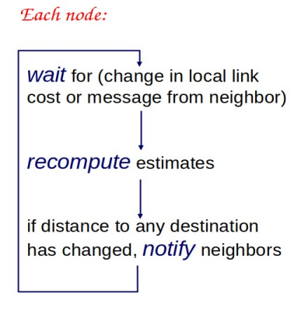

Local link cost change

Distance vector update message from neighbor

Distributed:

Each node notifies neighbors only when its DV changes

Neighbors then notify their neighbors if necessary

**18**

**19**Adopted from Computer Networks Topdown approach -Jim Ross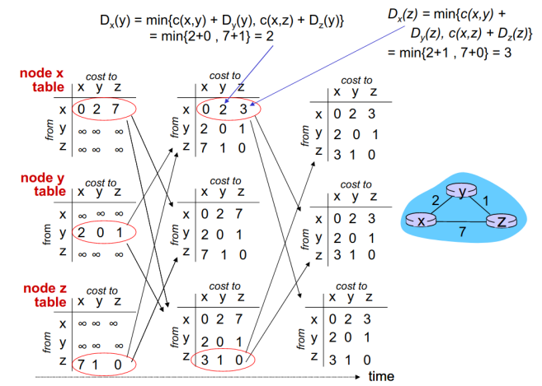

**Distance Vector link cost changes**

**20**

**Count to inifinity problem**

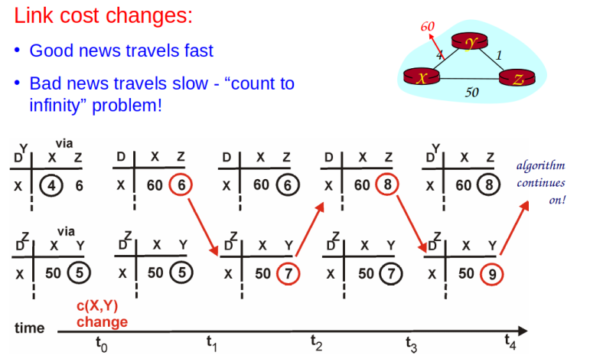**21**

**Solution -Poisoned Reverse**

12 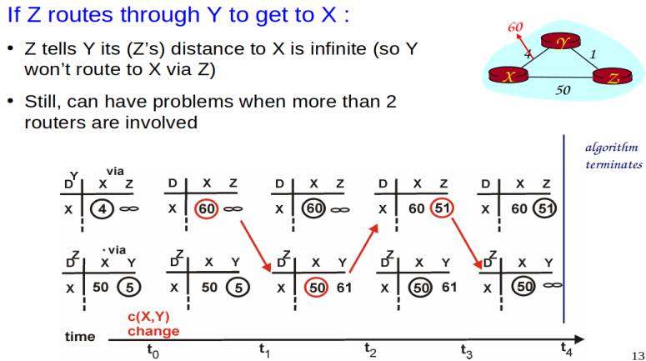

10

8

6

4

2

0

Row 1 Row 2 Row 3 Row 4

Column 1 Column 2 Column 3

**22**

**Flooding**

Probably one of the easiest ways to route the data. **“SEND TO ALL “.**

Leads to a large number of duplicate packets. Solution

-Include serial numbers.

-Include a counter which gets decremented on each hop.

**23**

**Link State Routing**

**The Distance vector routing protocol takes a large time to converge.**

**Each router has to do five primary tasks.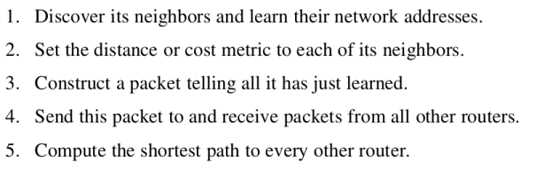24**

**When ever the router is booted special HELLO Packets are send to neighbouring routers.**

**The other routers are expected to reply with their identifiers.**

**The HELLO messages are generally send as brodcast messages.**

**So inorder to limit the transmission , an aging factor is added to the packet.**

**The link cost can generally be the delay which is measured from special ECHO packets send out.**

**The path calculation is done using dikstras algorithm.**

**25**

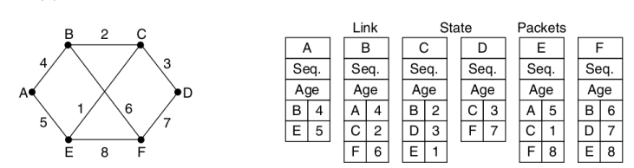**26**

**Hierarchial Routing**

**When the number of router grow it will become difficult to store all the informations on the router.**

**The routing table needs to be stored on the router to make decisions.**

**This can be only be a certain size.**

**To overcome this issue routers are organized as regions or in a hierarchial manner.**

**There could be atleast one router in a region which knows how to reach other regions.**

**27**

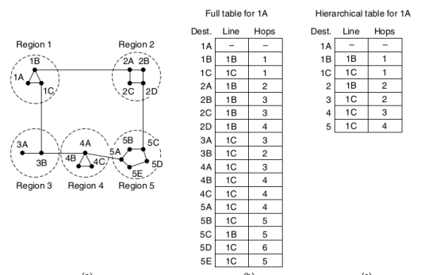**28**

**Broadcasting**

**Routing decisions when the same data has to reach multiple destinations.**

**One way is by using flooding.**

**Since there are wastages,other ways are used. 1. Reverse Path Forwading.**

**Router will not forward the information on the line in which it received the data.**

**2.Construct spanning tree.**

**29**

**Multicasting**

**Used when data has to be routed to a subset of routers.**

**The routers which desire to be in part of the scheme has to send special join messages.**

**Messages will be forwarded to those who are part of the group.**

**30**

**Routing in mobile host**

**A device with an IP address in one place will get another IP address in another place.**

**There could be situations when the old IP needs to be used.**

**A special entity known as Home Agent takes care of this issue.**

**Home Agent knows your present address and routes the information .**

**31**

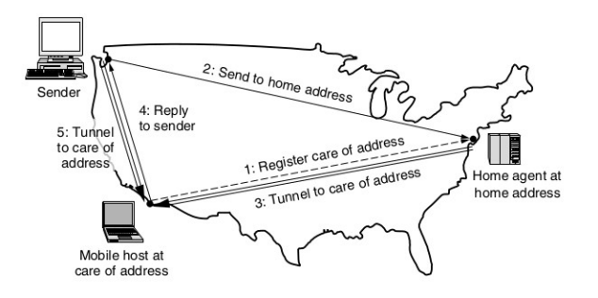**32**

**Things to think**

**- Routing in Mobile phones. -Routing in modile adhoc devices** -These are small low power devices

**33**

**Congestion Control Mechanism**

**The presence of too many packets in the network creates Congestion.**

**Congestion occurs when the source produces more packets than the destination could process.**

**This inturn affects the routers as they have to manage more traffic than they can handle.**

**All routers have buffers to temporarly store data. Once this buffer gets filled up data will be lost. As a result there will be performance degradation.**

**34**

**When congestion**

**increase delay**

**increase.** 

**When delay grows beyond a certain**

**extent the packets are of no use.**

**The sender may resend the data ,which adds up the congestion.**

**35**

**Solutions ???**

**Can we increase the speed of the router.?? Can we design a router with a large buffer ?? Can we use a faster medium ??**

**36**

**Solutions for dealing with congestion.**

**The basic idea is to design a network that can handle the load.**

**But that is not a single step process.**

**Many factors determine the transmission of the data.**

**37**

**Network Provisioning**

**Identify the weak points in the network and add resources is the key.**

**If there are known burst of activities at a certain period extra resources may be utilized.**

**If no such prior information is available this scheme will not be that effective.**

**38**

**Traffic aware routing.**

**Routers should asses the factors such as bandwidth,delay etc**

**The packets should be routed based on analysing conditions so as to avoid congestion.**

**The parameters has to be decided carfeully. If load alone is considered.**

-New path taken will redue the load.

-Once the load is less confusion arises on which route to take again.

**39**

**Admission Control**

**This is particularly applicable in virtual circuits where the path is pre established.**

**When the request for a new path arrives,this can be denied if the path is already congested.**

**There could be denial based on services which could generate a large amount of data packets.**

**40**

**Traffic throttiling**

**A way to avoid congestion is to detect the onset of congestion and take steps so that the data flow is controlled.**

**One metric is to measure the time spend by packets in a buffer.**



**Known as exponentially weighted moving average**

**41**

**Traffic throttiling**

**1.Using Choke Packets**

**The sender is informed about the congestion by sending a special choke packets.**

**The sender has to reduce the data rate once the choke packet is received.**

**2.Explicit Congestion Notification.**

**Rather than sending new packet, special bits are set in the packet.**

**Once it reaches the receiver ,congestion information is carried back on the reply message.**

**42**

**Traffic throttiling**

**3.Hop by Hop back pressure.**

**The information about the congestion may time to reach the sender.**

**The intermediate routers which see the congestion information are also made aware of the situation.**

**43**

**Load Shedding**

**The worst case.**

**Drop the packets if congestion happens.**

**The decision on which packet to drop depends on the application.**

**For video streaming present data is more important tahn old data.**

**44**

**Random Early detection**

**When the router finds that the queue length has grown beyond a treshold ,it will drop packets.**

**Packets are chosen at random**

**It is assume that faster sender will notice the drop and will resend.**

**The transport layer protocol has mechanisms to slow down the sending.**

**45**

**Quality of service**

As far as any network is concerned ,users require to get data within minimum time.

They do not tolerate any loss of data also.

There are four parameters that define the Quality of service.

1.Bandwidth

2.Delay

3.Loss

4.Jitter --> Variations in delay

**46**

**Contd**

A stream of packets that move from source to destination is know as **flow**.

Every application sends a stream of information to the destination.

The QoS parameters will vary based on the application.

For example a video conference application will be highly sensitive to jitter,delay,low bandwidth and loss

Meanwhile a file transfer service will be less sensitive to the parameters.

**47**

**Traffic shaping**

One major problem that is encountered is sudden burst of packet flow. (Bursty traffic )

They cause the incoming data rate to fluctuate at the routers.

As a result the routers may not be able to handle some data resulting in loss and delays.

One solution is to make the sender transmit data onto the network at a constant rate

**48**

**Traffic shaping**

**Leaky Bucket Algorithm**

Imagine a bucket with a small hole in the bottom.

When there is water in the bucket the output flow will be at a constant rate **R.**

When there is more water there will be spillage and loss.

Translate water to data.

The output will be at a constant rate.

Additional buffers may be employed at source to prevent loss.

**49**

**Traffic shaping**

**Token Bucket algorithm**

Here the bucket is filled at a constant rate. And tokens or data are retreived from the bucket. The removal follows a pattern.

**In both the cases ,the overall idea is to reduce uneven flow rate.**

**As a result there could be addition of minimal delay.**

**50**

**Packet Scheduling**

The routers are required to store and process packets before transmitting them.

There are three resources that needs to be allocated 1.CPU

2.Bandwidth.

3.Buffer space.

There could be buffer selection algorithms that select packets from buffer.

**51**

Packets could be selected using FIFO.

But there could be packets belonging to delay sensitive applications.

The routers may use multiple queues. Specific weight could be given to queues also.

**52**

**Admission Control**

Applications are required to provide the Quality parameters .

This scheme works well in a virtual circuit scheme.

Routers can determine if they can meet the requirement .

If the requirements are within range connection is allowed.

There are specific protocols to negotiate the parameters.(RFC 2210,2211

**53**

**Resource Reservation Protocol (RSVP)**

Mainly used in multicast networks.

Multicast receivers may require to switch between applications.

Protocol uses a multicast spanning tree.

The transmission is done by specifying group address as destination.

Any receiver in the group can send up reservation request using reverse path forwarding.

Routers which get the data try to allocate resources.

**54**

**55**

**Differentiated Service**

Users are added to different classes.

Each class of service given specific QoS parameters.

The classes are defined as per hop behaviour.

This may not be true among all the routers.

For Example Gold class customers getting less delay,more bandwidth. RFC 3246 defined expedited and regular flow.

**56**

**57**